Graph. Normal  - Roads Count  - Find a ring road  - Is there another country? | Graph. Advanced  - Find a ring road  - Path from near side to far side  - Is there another country?

Graph. Normal
In Milky Way galaxy there is a planet Neptune with N cities. Some of them are connected with roads.
Adjacency matrix - matrix N*N, for each pair of cities you have 1 or 0: if i-th city is connected with k-th city by road - 1, otherwise - 0.
Adjacency list - you have a list with pairs of connected roads
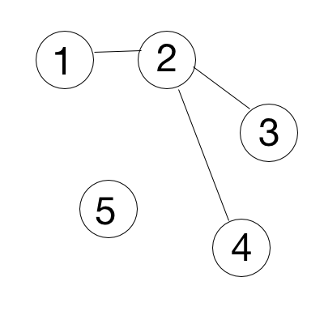
- Roads Count. You need to print out a count of roads by given adjacency matrix. Input: 1st row - N, number of cities, next N rows - adjacency matrix.
Input: Output:
5 3
0 1 0 0 0
1 0 1 1 0
0 1 0 0 0
0 1 0 0 0
0 0 0 0 0
Solution:
Questions to discuss: 1. Oriented vs not oriented -> is symmetric matrix or not. 2. How does matrix change If there are several roads between cities(a[i][j] = 3 or a[1][1] = 5)
Not oriented graph: count all values and divide by 2. Oriented graph: count all values
def roadcount(a):
res = 0
for i in range(len(a)):
for k in range(len(b)):
res += a[i][k]
res = res / 2 # in case of not oriented graph
return res

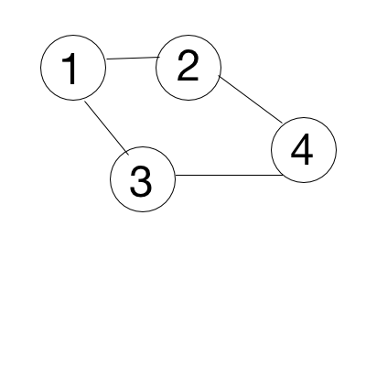
- Find a ring road. You need to print “Ring road” if there are roads that make a ring road, “Tree structure” - otherwise. Input: 1st row - N, number of cities, next N rows - adjacency matrix.
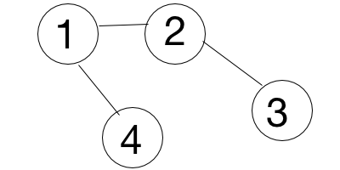
Input: Output: Input: Output:
4 Ring road 4 Tree structure
1 1 1 0 1 1 0 1
1 1 0 1 1 1 1 0
1 0 1 1 0 1 1 0
0 1 1 1 1 0 0 1

Solution:
Questions to discuss: Are all cities connected?
You need to traverse through a graph by DFS (Depth First Search). If you find a vertex that you’ve already seen - there is a loop.
def find_loop(a, v, seen):  if v in seen:  return true  seen.append(v)  hasLoop = False  for i in a[v]:  hasLoop = find_loop(a, i, seen)  if hasLoop: break  return hasLoop | def solve(a, N):  seen = []  for i in range(N):  if i not in seen:  hasLoop = find_loop(a, i, seen)  if hasLoop:  print “Ring Road”  return  print “Tree structure”

- Is there another country? If two cities are connected, they belong to the same country. You need to check if there is only one country on a planet. Print YES - if only one, NO - otherwise. Input: 1st row - N, K, where N - number of cities, K - number of roads, next K rows - adjacency list.
Input: Output: Input: Output: Input: Output:
5 4 YES 1 0 YES 5 2 NO
1 2 1 2
3 4 4 5
5 2
4 5
Solution:
Questions to discuss: In which cases adjacency list is better than adjacency matrix. What is difference between BFS and DFS? What is a connected component?
Traverse with BFS and then compare count of all seen vertices with N. If they are not equal - there is more than 1 connected component

Graph. Normal  - Roads Count  - Find a ring road  - Is there another country? | Graph. Advanced  - Find a ring road  - Path from near side to far side  - Is there another country?

Graph. Advanced

- Find a ring road. Some of those roads are one way roads. You need to print “Ring road” if there are roads that make a ring road, “Tree structure” - otherwise. Input: 1st row - N, number of cities, next N rows - adjacency matrix.

1
2
3
4
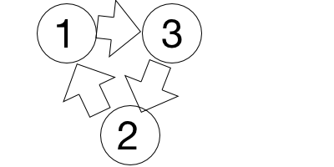 | Input:  3  1 0 1  1 1 0  0 1 1 | Output:  Ring road | Input:  4  1 0 1 1  0 1 0 0  0 0 1 0  0 0 0 1 | Output:  Tree structure

Questions to discuss: Are all cities connected?
Solution: traverse through a graph by DFS (Depth First Search). If you find a vertex that you’ve already seen - there is a loop.

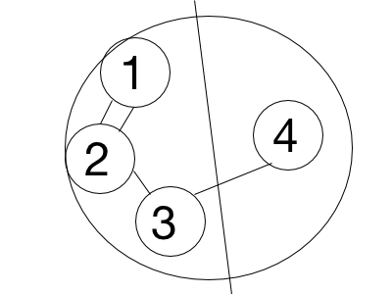
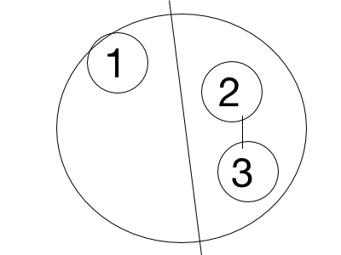
- Path from near side to far side. Some cities are on the near side of Neptune, others are on the far side. Print ”YES” if there is a path from the near side to the far side, otherwise - “NO”. Input: 1st row - N, M, K, where N - total number of cities, M - number of roads, K - number of cities on the near side, 2nd row - the list of K cities on the near side, next M rows - adjacency list of roads.
Input: Output: Input: Output:
5 4 3 <- 5 cities, 4 roads. 3 cities near side YES 3 1 1 NO
1 2 3 <- the 3 cities on near side 1
1 2 2 3
2 1
2 3
3 4
Solution: for each vertex from near side find connected component that it belongs to. If some component has vertices from both sides - there is a way.
Optimization: while looking for connected components - check if all vertices from the same side. if not - found a way and you can stop.
Questions to discuss: What is a connected component? What is difference between BFS and DFS? When adjacency list is better to use than matrix?

- Is there another country? If two cities are connected, they belong to the same country. You need to print all cities for each country. Input: 1st row - N, K, where N - number of cities, K - number of roads, next K rows - adjacency list.
Input: Output: Input: Output: Input: Output:
5 3 1 2 5 1 0 1 5 2 1 2
1 2 3 4 1 2 3
3 4 4 5 4 5
5 2
Questions to discuss: What is a connected component? What is difference between BFS and DFS? When adjacency list is better to use than matrix?
Solution: find all connected components by DFS/BFS. Print all vertices for each component.

Depth First Search
Write a depth-first search algorithm for a graph represented as an adjacency list.
Extra question: What is the running time for DFS if we use an adjacency matrix instead of adjacency lists?

Solution (http://www.cs.princeton.edu/courses/archive/spr15/cos226/lectures/41UndirectedGraphs.pdf)
DFS (to visit a vertex v):
・ Mark vertex v
・ Recursively visit all unmarked vertices adjacent to v
.
Data structures.
・ Boolean array marked[] to mark vertices.
・ Integer array edgeTo[] to keep track of paths.
(edgeTo[w] == v) means that edge v-w taken to discover vertex w
・Function-call stack for recursion.

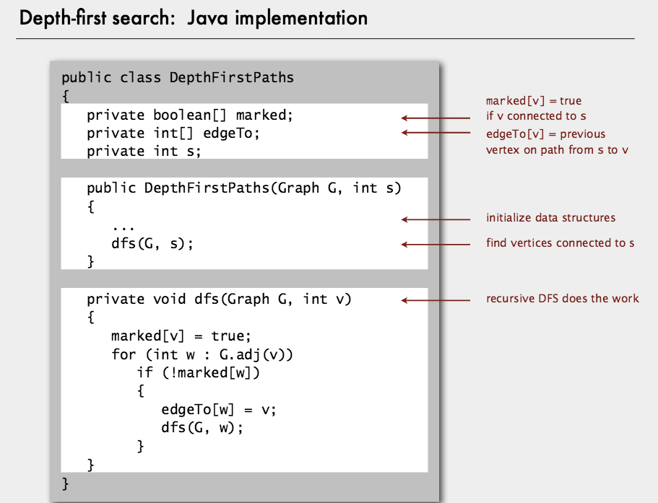

Breadth First Search
Write a breadth-first search algorithm for a graph represented as an adjacency list. Extra question: What is the running time for BFS if we use an adjacency matrix instead of adjacency lists?

Solution (http://www.cs.princeton.edu/courses/archive/spr15/cos226/lectures/41UndirectedGraphs.pdf)
